1. . Create a Storage service using any Public Cloud Service Provider (Azure/GCP/AWS) and check the public accessibility of the stored file to demonstrate Storage as a Service.

OUTPUTS :-

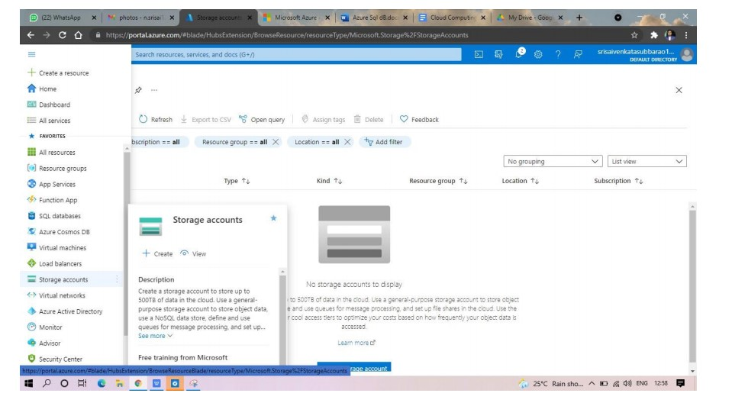

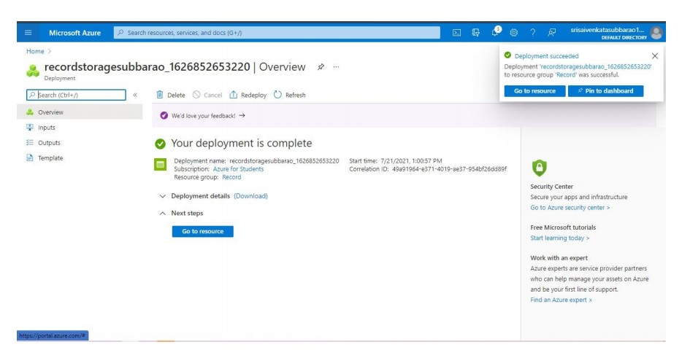

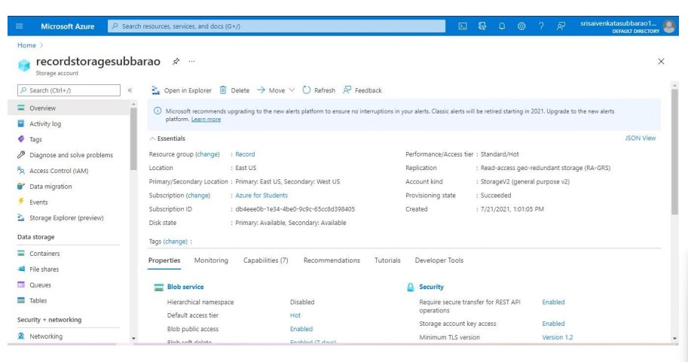

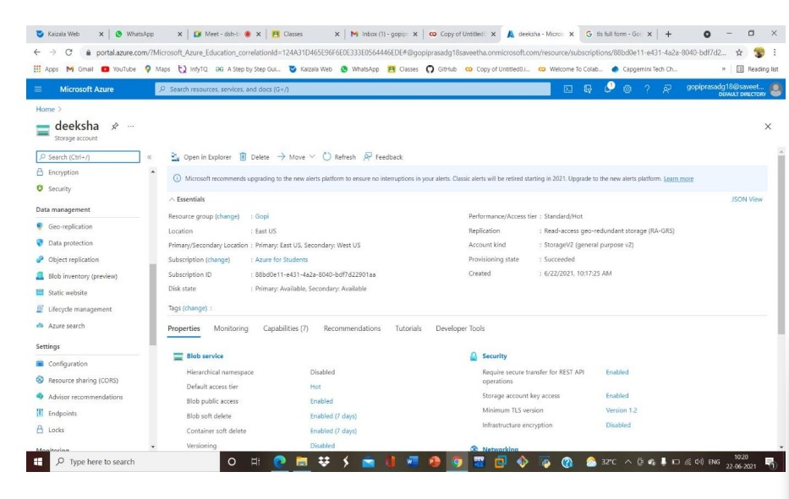

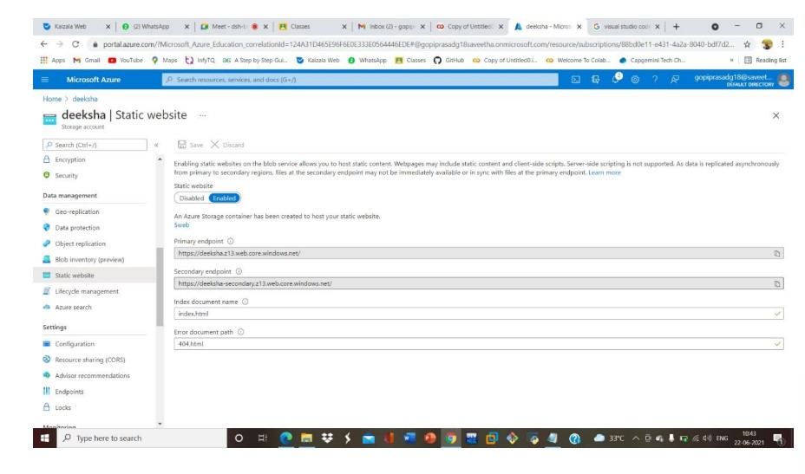

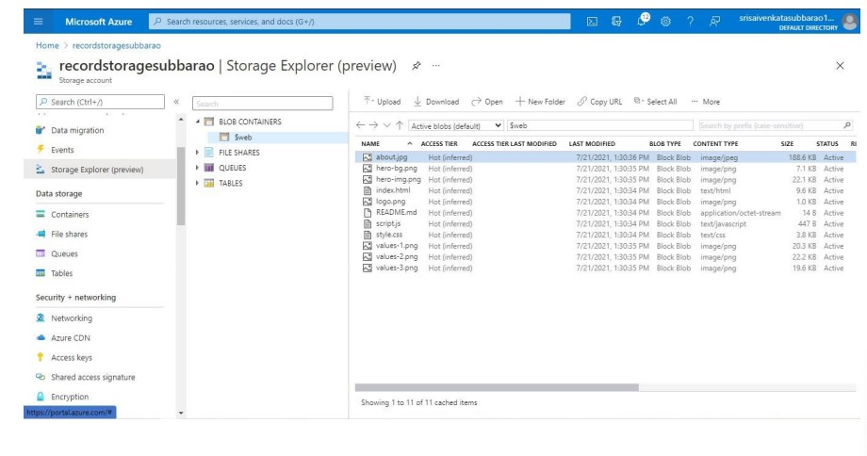

We offer modern solutions for growing your business

We are team of talented designers making websites with dootstrap